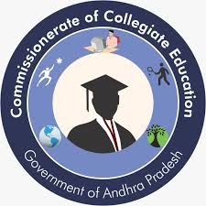**Government Degree College, Porumamilla**

**Dept. of Commerce & Computer Applications**

**Activities 2022-2023**

|  |  |
| --- | --- |
| **1. Name of the Activity** | **International Yoga Day** |
| **2. Name of the Lecturer** | **D.Narasaiah** |
| **3. Date** | **21/06/2022** |
| **4. Number of students participated** | **30** |
| **5. Number of faculty involved** | 6 |
| **6. Aim & Objectives :**  **To raise awareness about the benefits of yoga and promote healthy lifestyles.** | |
| **7. Brief Report;-**  **GDC-PORUMAMILLA is Very much delighted to share that we have observed International Yoga Day in our college today. It was organised by the department of Commerce & Physical Education. The students and staff under went exercising of Surya namaskarams and asanas. Sri. Siva Reddy lec.in History and the special invitee Sri. Balarangaiah, The Head Master, demonstrated the event successfully. The Principal explained the significance of the day and the theme. Yoga for Women Empowerment . It makes everyone hale and healthy.**      **Signature of the Dept in Charge:** | |
| International Yoga Day 2023 | |
|  | |
|  | |

|  |
| --- |
|  |
| **Signature of the Dept. in Charge:** |